JRE – Java Runtime Environment enables Java code execution.

JDK – Provides tools required to create Java applications.

IDE – Integrated Development Environment (InteliJ).

**Primitive Data Types**

There are four categories of primitive data types:

* Integer
* Floating point
* Character
* Boolean

Integer types:

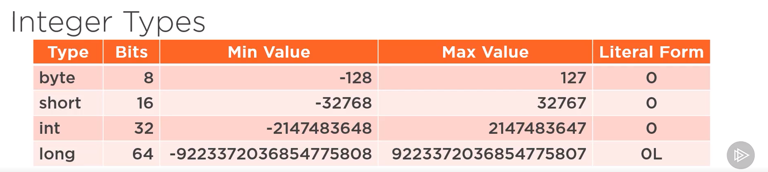

Floating point types:

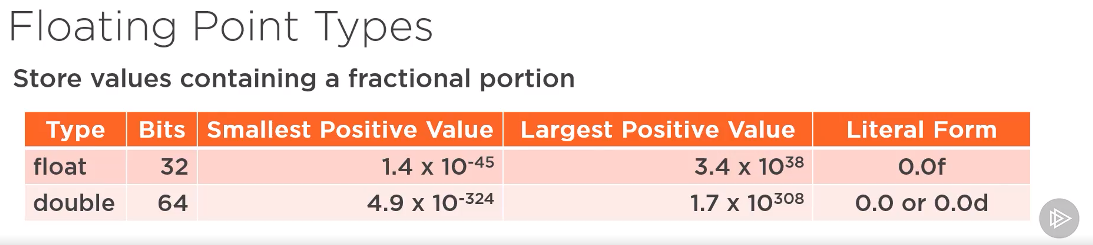

Character type:



Boolean type:



**The var keyword**

The var keyword infers the type of a local variable based on the value initially assigned to it.

var v1 = 50; // v1 is an int

var myValue – 100.0; // myValue is a double

int i = 25;

var total = i + v1; // total is an int

It is not allowed to do something like this: var x; x = 100; Because the compiler does not know at declaration time what the type of x supposed to be.